Name: Date: ea words 3

The long (e) sound is often represented by the letters ea when it comes in the middle of words, like in the words below.

Remember: Say the word aloud, then say each letter aloud as you write it e.g. 'feast, f ... e ... a ... s ... t'

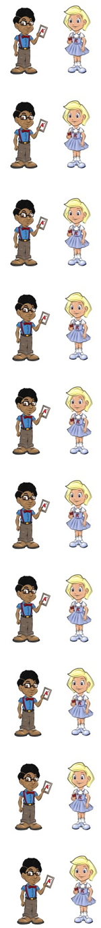
A feast is a meal for lots of people.

Which teacher gives the least homework?

To play a drum you beat it.

A treat is something nice, like an ice-cream.

Heat can make things melt.

Meat comes from animals.

A seat is another word for a chair.

If you cheat, you do not stick to the rules.

A reason is why you do something.

There are three months in each season.

Now test yourself without looking at the words and check for yourself if you got them all right. Practice writing any words that you made mistakes on again.

© www.SaveTeachersSundays.com 2013
Name: Date: ea words 3

The long (e) sound is often represented by the letters ea when it comes in the middle of words, like in the words below.

Remember: Say the word aloud, then say each letter aloud as you write it e.g. 'feast, f ... e ... a ... s ... t'

Try to spell each word without looking at it.

A is a meal for lots of people.

Which teacher gives the homework?

To play a drum you it.

A is something nice, like an ice-cream.

can make things melt.

comes from animals.

A is another word for a chair.

If you , you do not stick to the rules.

A is why you do something.

There are three months in each .

Now check for yourself if you got them all right. Practice writing any words that you made mistakes on again.

© www.SaveTeachersSundays.com 2013

